Assignment-1

Connect and disconnect with login Access  
  
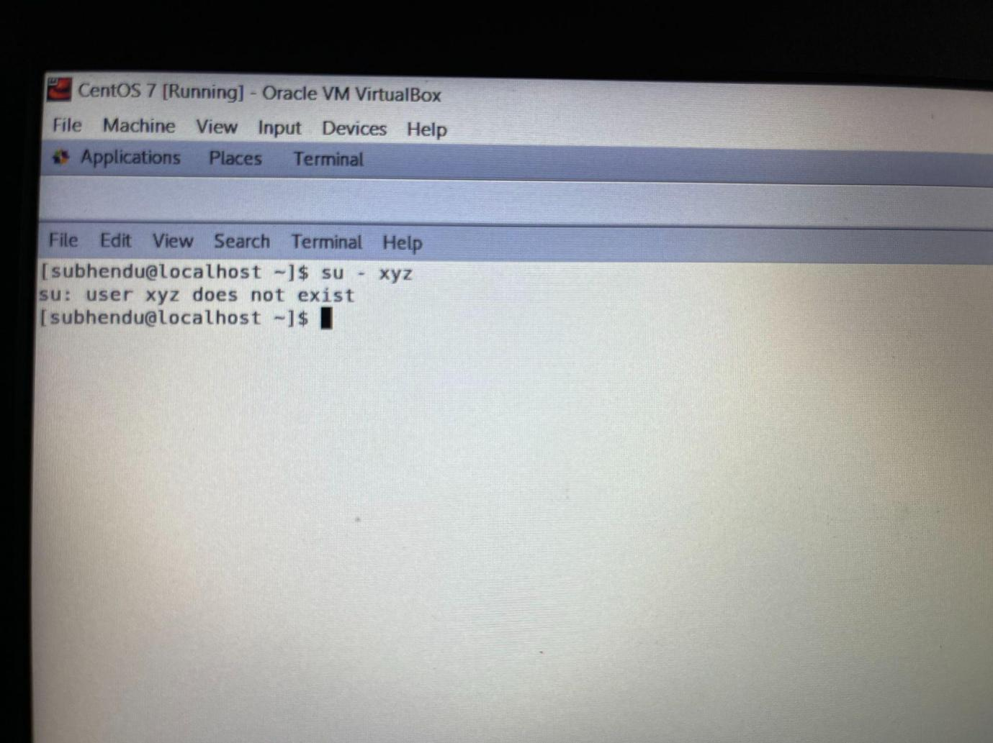  
**1. What happens when you login a non-existent users or username?  
Explanation:** Tried to login with a non-existent user so throwing message “su: user {username} does not exist.”

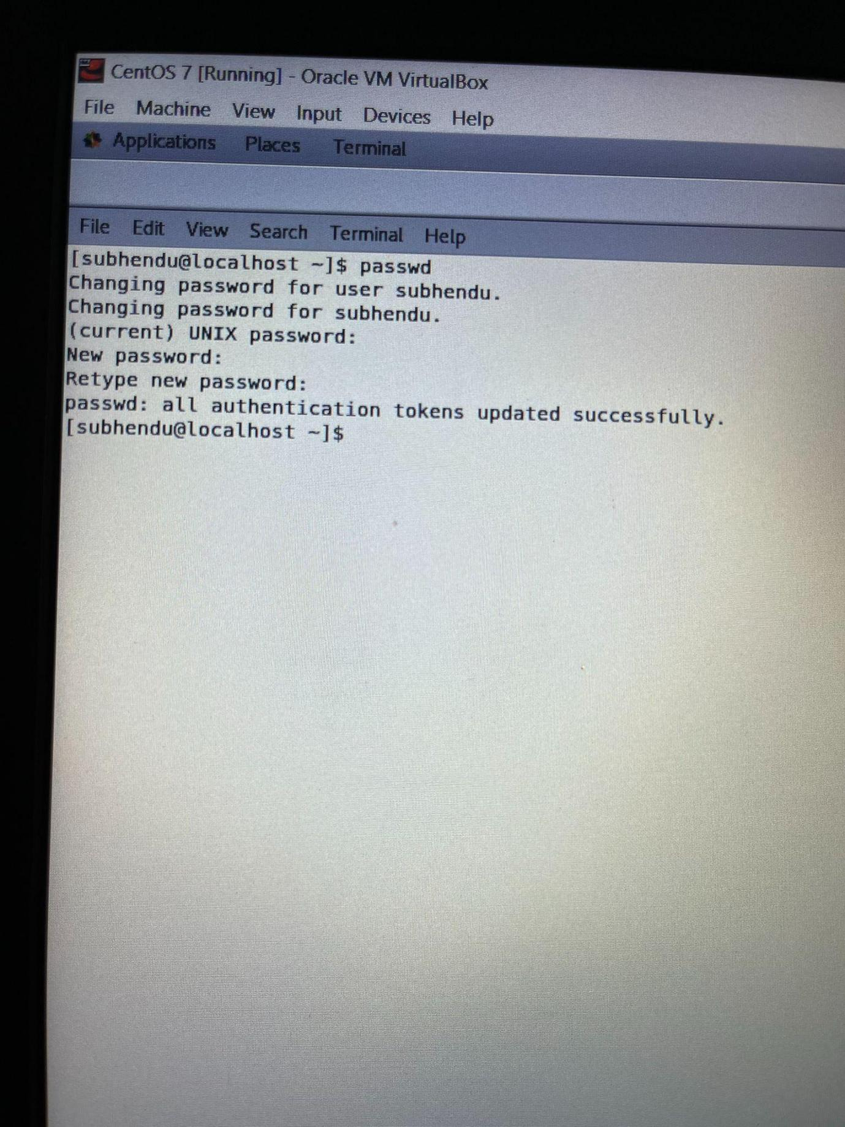  
**2. Change your password into IneuR0n#42 and hit the Enter key  
Explanation:** Here, the first command was “passwd” & then hit Enter. First it has asked for the “current” UNIX password. Then it asked for “New Password” & “Confirm New Password”. **Enter IneuR0n#42 as the** “New Password” & “Confirm New Password” & hit “Enter” then Got the success message “all authentication tokens updated successfully.”***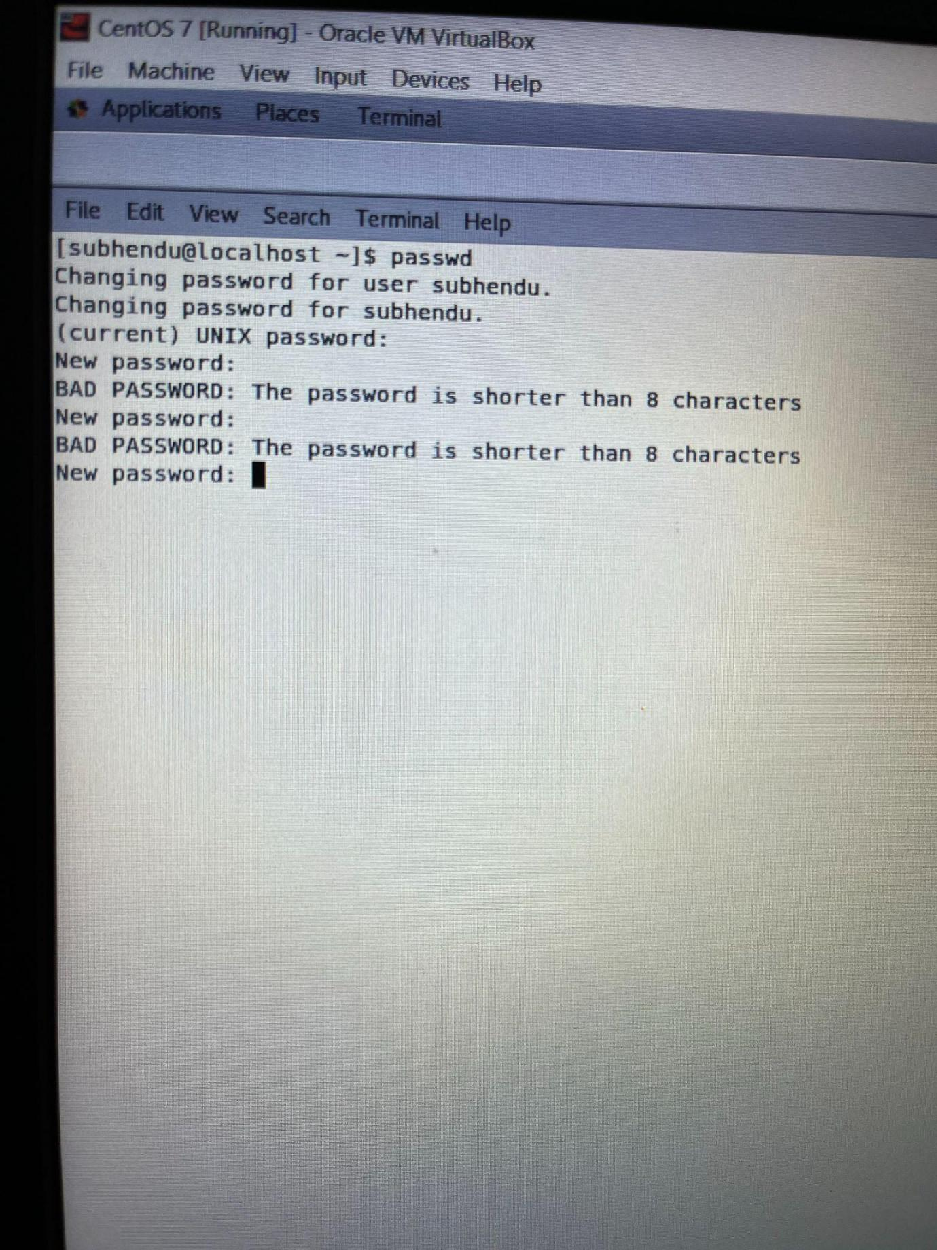*3. Try again to change password but use like password 1234 or abcd.  
Explanation:**Here, tried to change the “New Password” & the “Confirm New Password” with invalid passwords like “1234” / “abcd” & hit “Enter”. Getting message as “The password is shorter than 8 characters”. Min length of password must be 8 characters. ***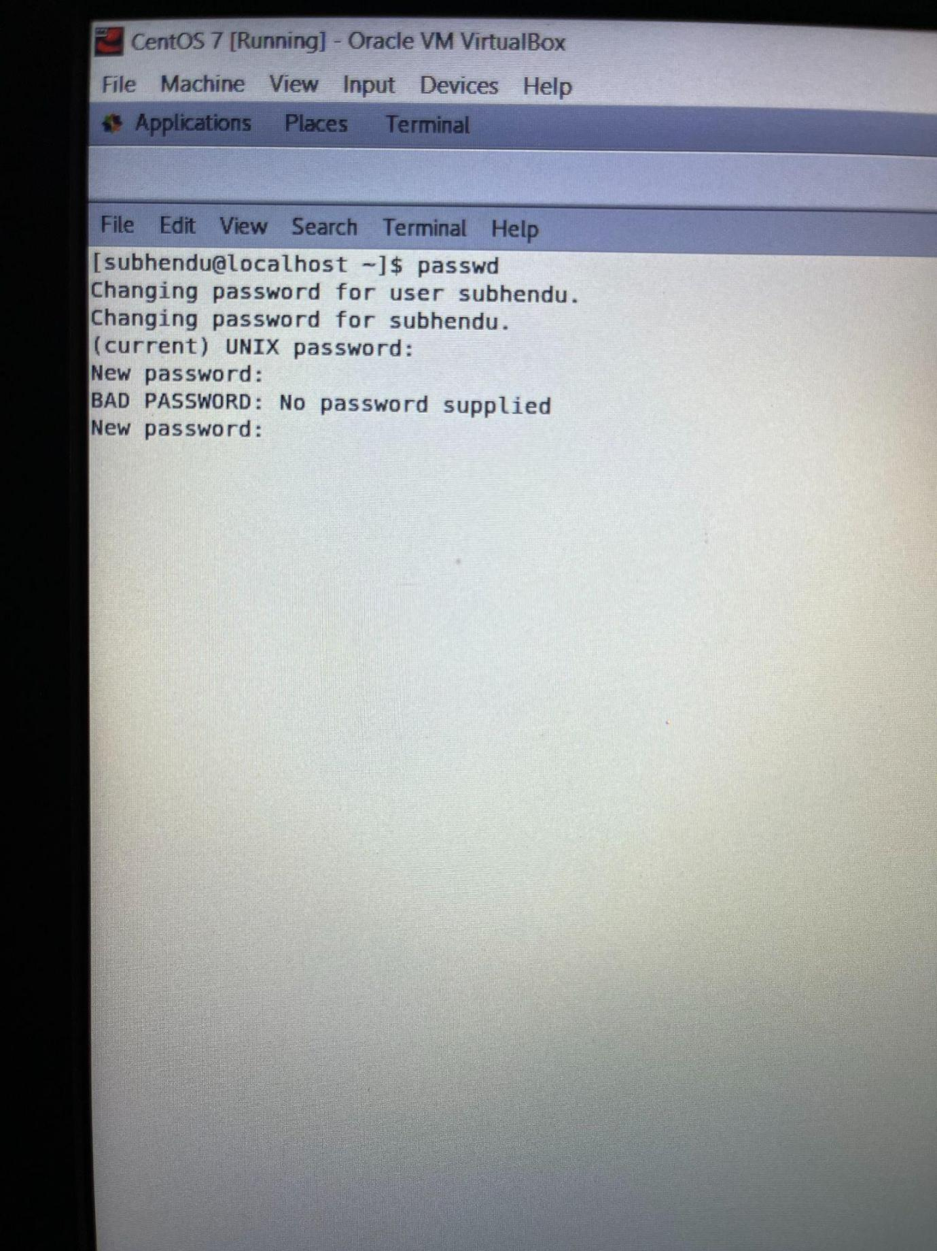*4. Try again to change password but now don’t use any password just hit Enter key  
Explanation:Here,** didn’t use any password just hit **Enter** key & getting the output as “BAD PASSWORD: No password supplied” **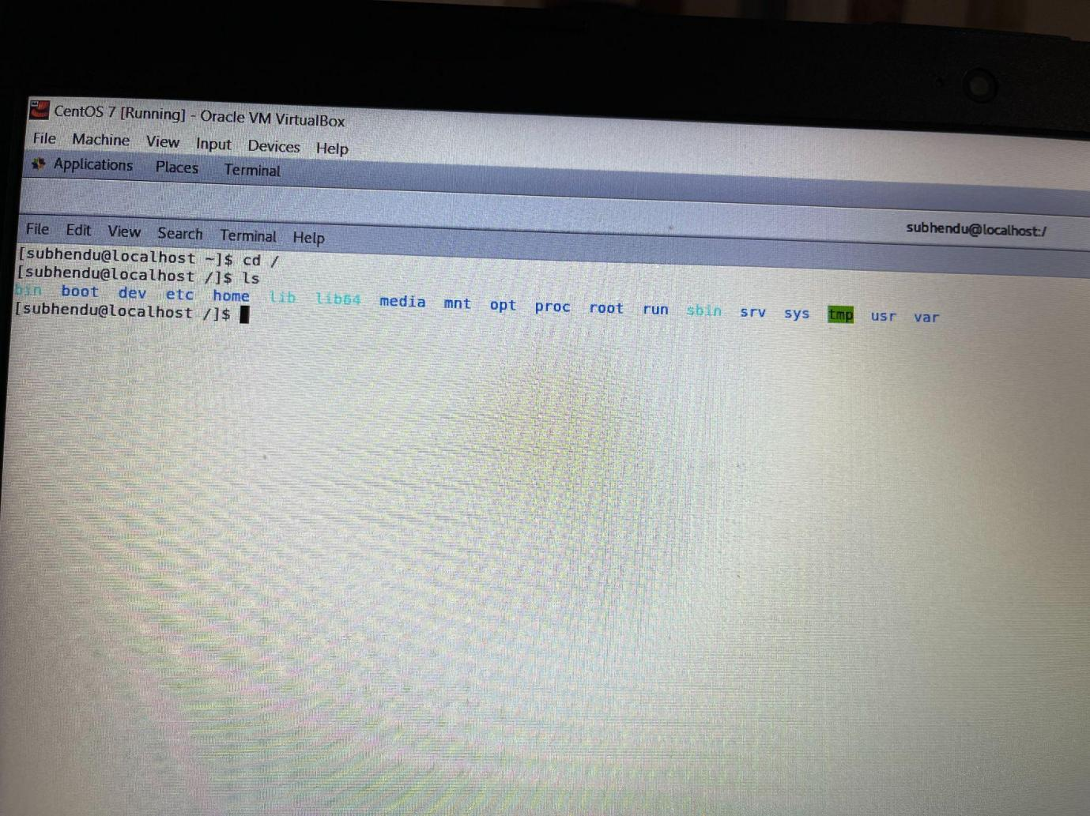  
5.** Enter the command **cd /** and then **ls** and then hit **Enter** key  
Explanation: cd command in linux known as **change directory command**. It is used to change current working directory. Here, “/” is the root directory/folder. “Cd /” change the directory to the root directory. “ls” command to list directories.

**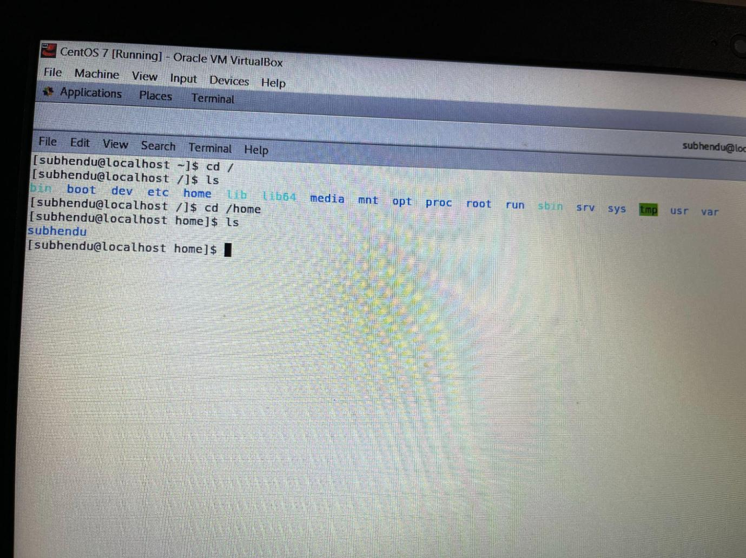  
6.** Enter the command now **cd /home** and then hit **Enter** key  
Explanation: Here, **/home** is **a directory for a particular user of the system and consists of individual files**. It is also referred to as the login directory. This is the first place that occurs after logging into a Linux system.

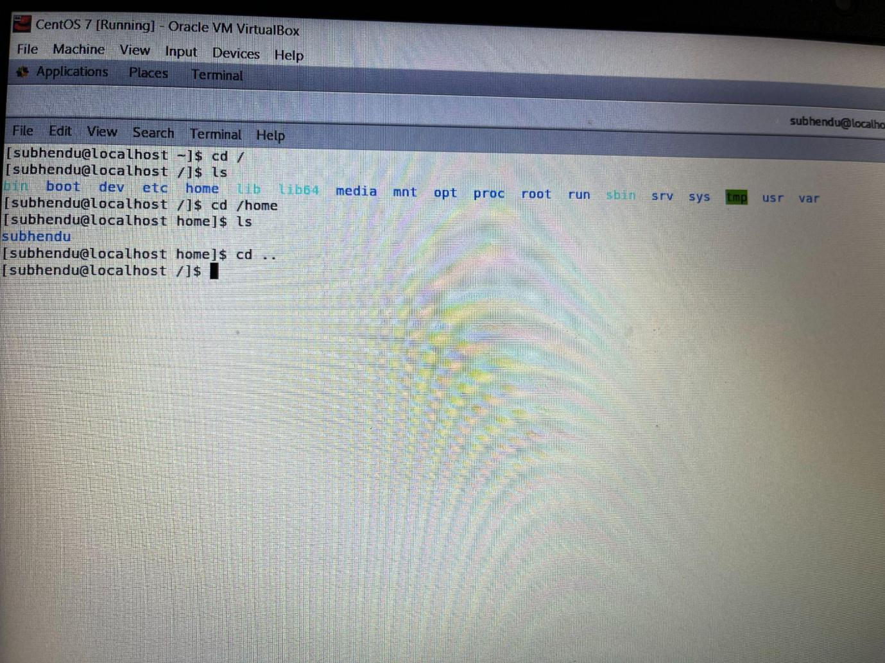

7. Enter **cd ..** and hit **Enter** key [ *Note: here we have space after cd then use double dot*].  
Explanation: This command is used to move to the current directory, or the directory one level up from the current directory. Here, “..” represents the parent directory.

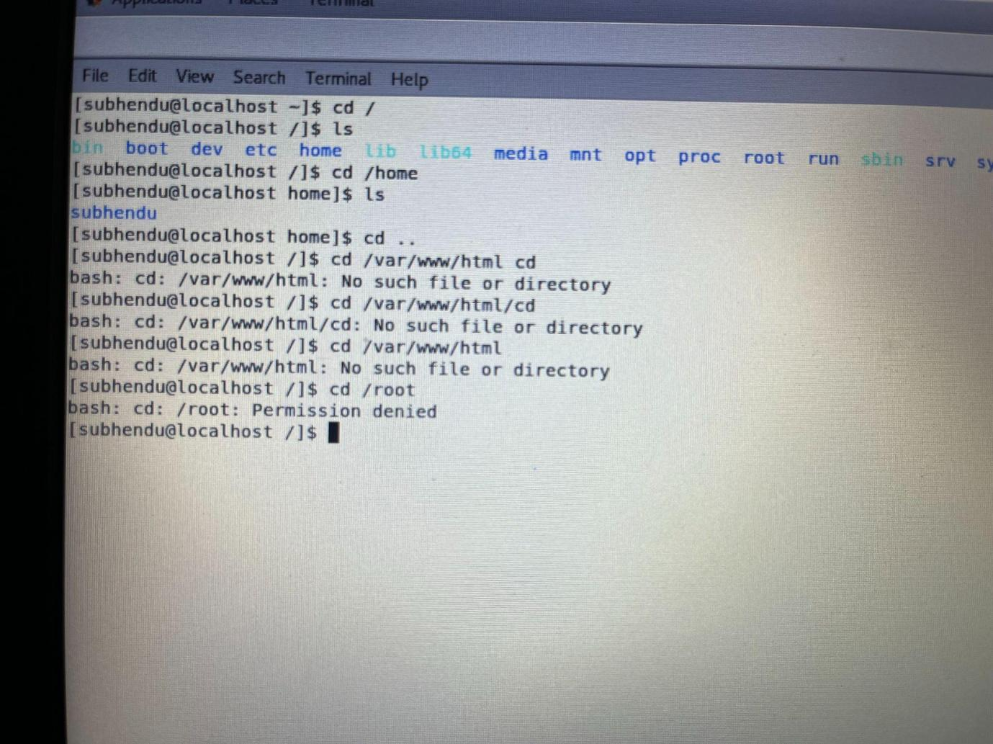

**8.** Now enter **cd /var/www/html** and then type **cd** and hit **Enter** key  
Explanation: Sorry did not get the question exactly but, what **cd /var/www/html** do here is move the directory to var/www/html where, “html” is the current directory.  
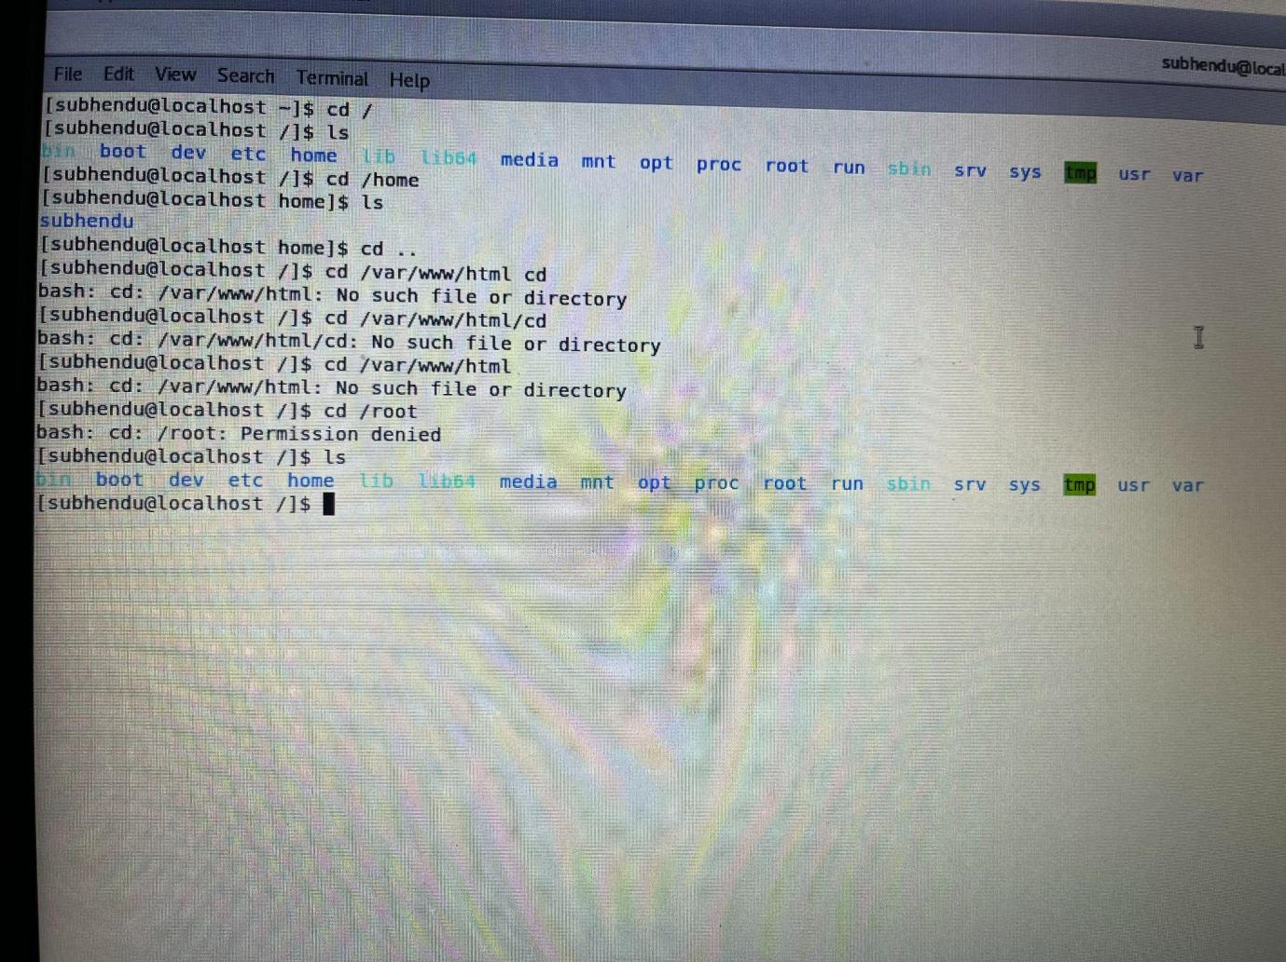  
9. Now type **cd /root** and then hit **Enter** key  
Explanation: First, cd /root command move the directory to root directory. Then “ls” command, listout all the directories present inside “root” directory.  
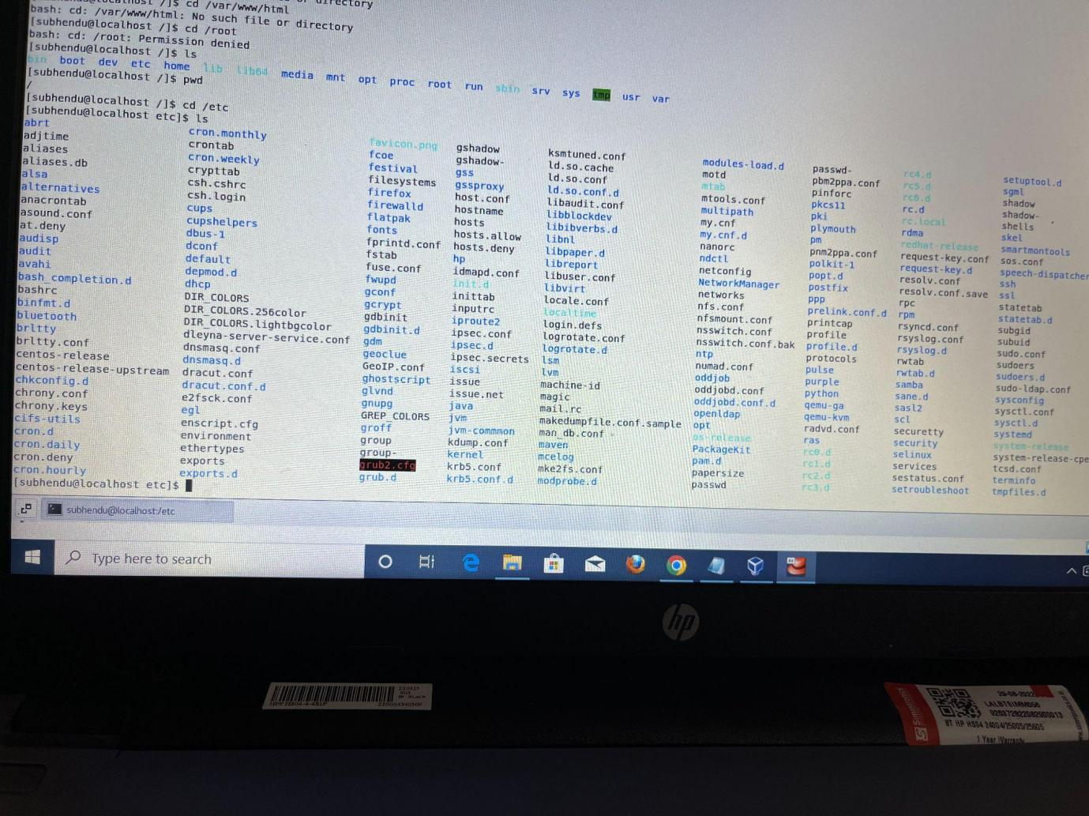  
 —Working with File Listing—  
→ Go to **cd /etc** and type **ls  
Q.** what files you have seeing?

**Ans:** /etc, Contains system-wide configuration files and system databases; **Q.** what different output you found compare to previous command you used?

**Ans:** A large number of files & system databases displayed on the screen when we change the directory to “etc” & do “ls”. **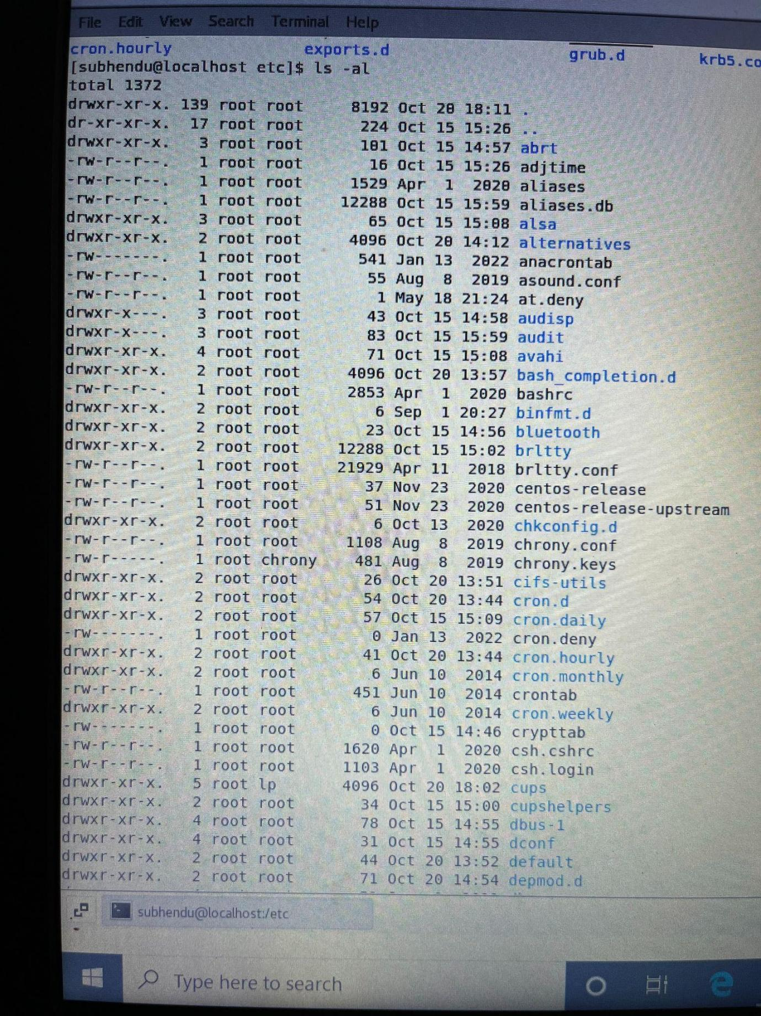  
→** Type **ls -al** and hit **Enter** key  
Q. Explain what new file or directory you found?  
Ans: It will return all the hidden files, or files starting with . in that directory. To view all files (including hidden) in a directory.

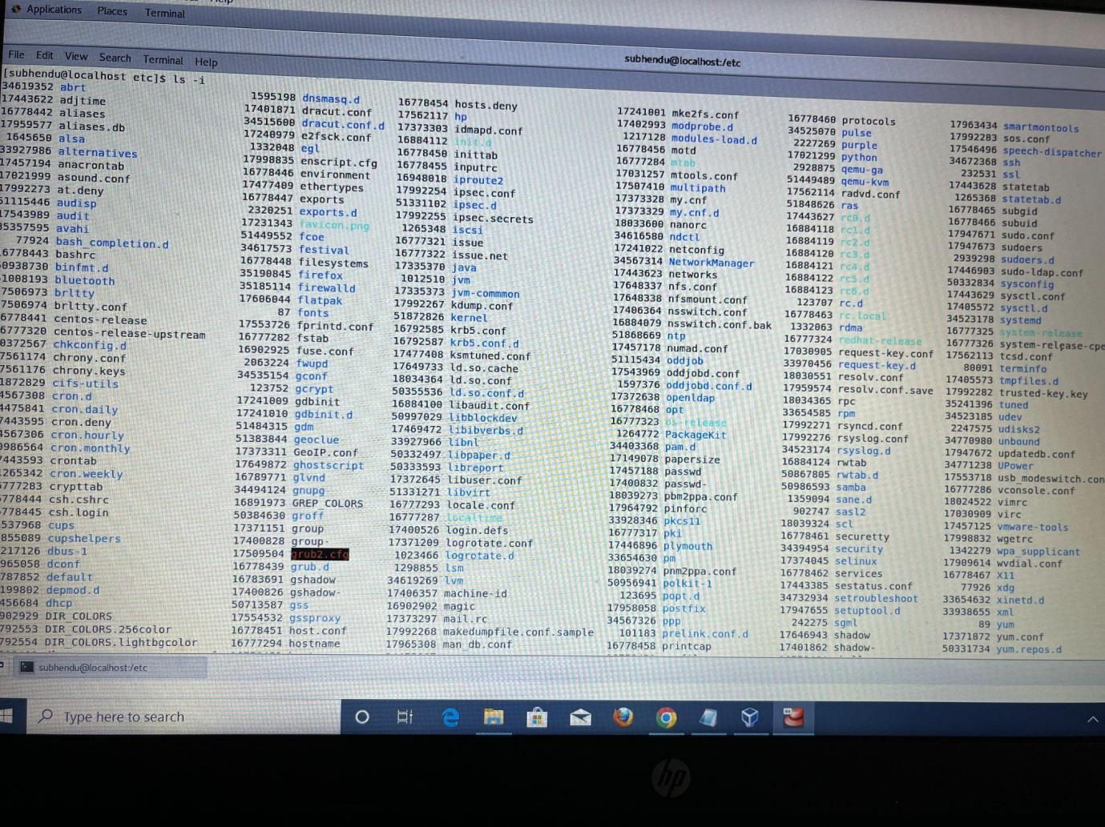  
→ Use **ls -i** and hit **Enter** key  
Q. what different output its shows and take screenshot?

Ans: It will list file's inode(index) number. In **Unix based** operating system each file is indexed by an **Inode**. Inode are special disk blocks they are created when the file system is created. The number of Inode limits the total number of files/directories that can be stored in the file system.

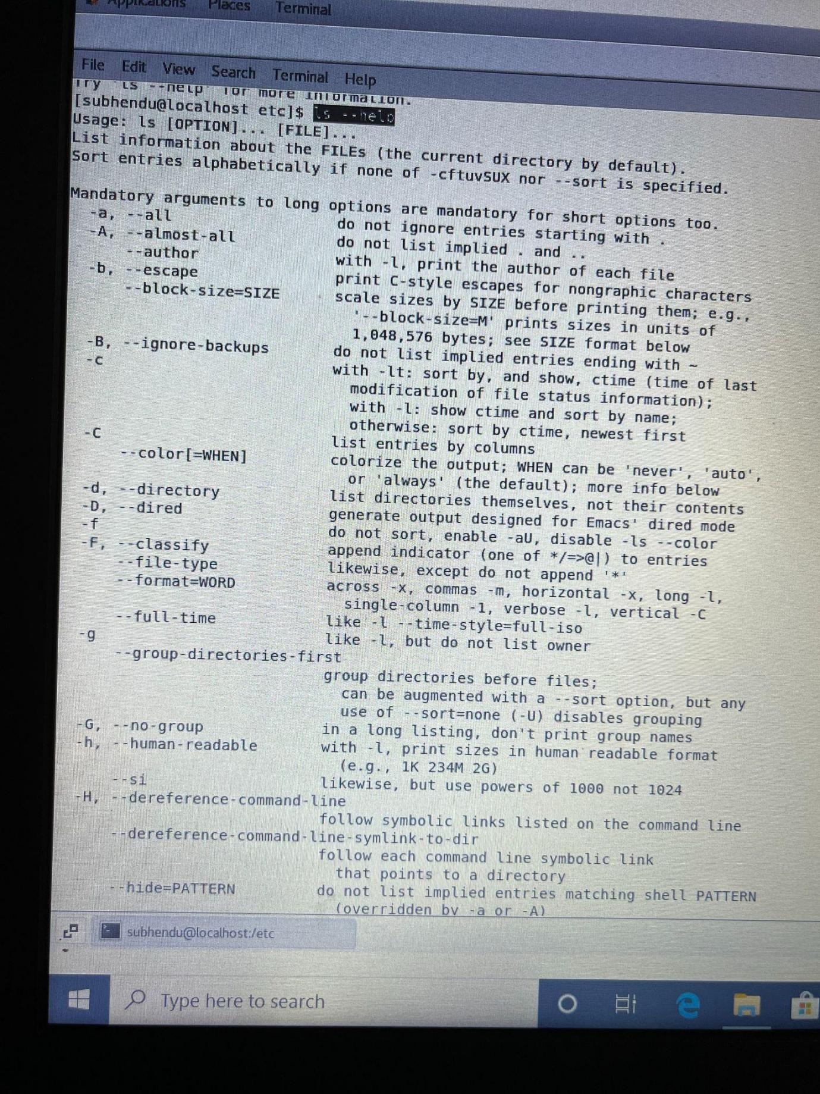  
→ Use **ls –help** and see other options about **ls** command  
Explanation: This command displays the uses of all commands basically. 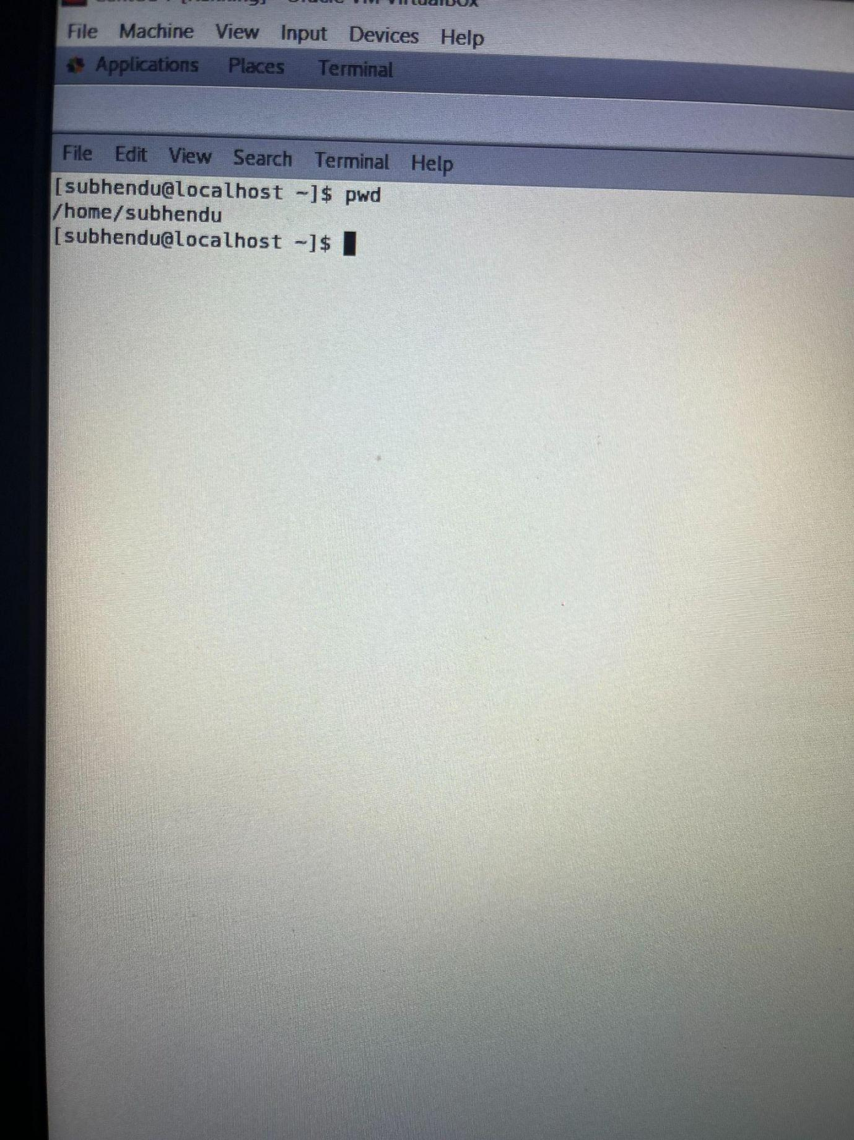  
Know where you are and where you working

Type pwd → Enter  
Explanation: **“pwd” stands for** *present working directory.* It prints “present working directory”.  
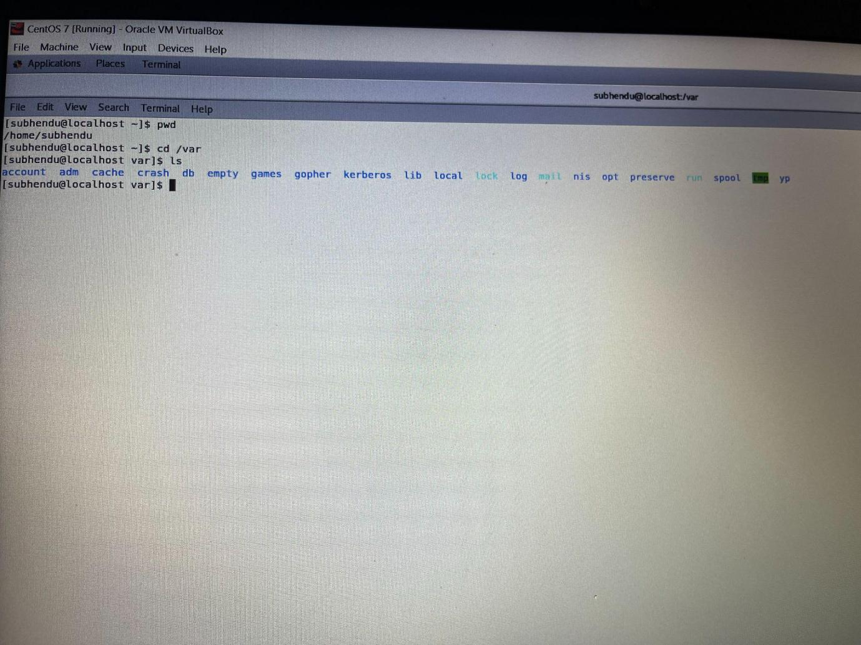  
→**cd /var** and hit **Enter** key  
Do **ls,** and see what output comes, give screenshot?  
Explanation: /var This directory contains files which may change in size, such as spool and log files.